Supporting Information
Rec. Nat. Prod. X:X (2019) XX-XX
New Oxoprotoberberine and Aporphine Alkaloids from the Roots of Amoora cucullata with Their Antiproliferative Activites

Parinuch Chumkaew*, Passakorn Teerapongpisan, Jaraslak Pechwang and Theera Srisawat
Faculty of Science and Industrial Technology, Prince of Songkla University, Suratthani
Campus, Suratthani 84000, Thailand

Table of Contents | Page
Figure S1: ¹H-NMR (500 MHz, CDCl₃) Spectrum of Compound 1 (Amocurine A) | 2
Figure S2: ¹³C-NMR (125 MHz, CDCl₃) Spectrum of Compound 1 (Amocurine A) | 2
Figure S3: HMBC (500 MHz, CDCl₃) Spectrum of Compound 1 (Amocurine A)  Figure S4: HRESI-MS Spectrum of Compound 1 (Amocurine A)  Figure S5: ¹H-NMR (500 MHz, CDCl₃) Spectrum of Compound 2 (Amocurine B) | 3  3  4
Figure S6: ¹³C-NMR (125 MHz, CDCl₃) Spectrum of Compound 2 (Amocurine B) | 4
Figure S7: HMBC (500 MHz, CDCl₃) Spectrum of Compound 2 (Amocurine B) | 5
Figure S8: HRESI-MS Spectrum of Compound 2 (Amocurine B) | 5
Figure S9: ¹H-NMR (500 MHz, CDCl₃) Spectrum of Compound 3 (Amocurine C)  Figure S10: ¹³C-NMR (125 MHz, CDCl₃) Spectrum of Compound 3 (Amocurine C)  Figure S11: HMBC (500 MHz, CDCl₃) Spectrum of Compound 3 (Amocurine C) | 6  6  7
Figure S12: HRESI-MS Spectrum of Compound 3 (Amocurine C) | 7

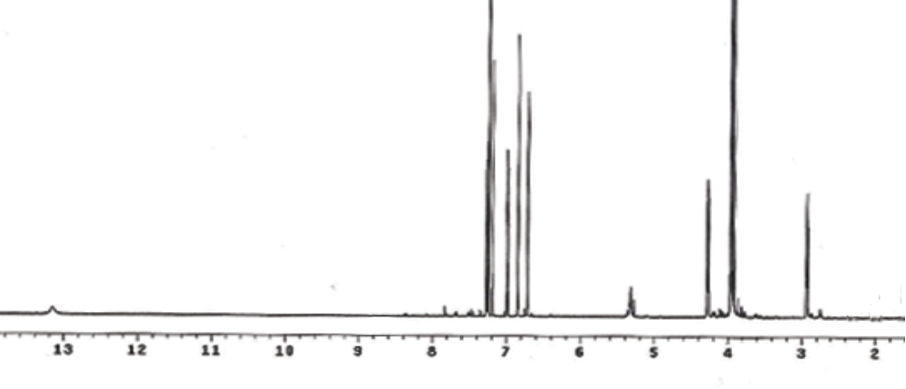

Figure S1: ¹H-NMR (500 MHz, CDCl₃) Spectrum of Compound 1 (Amocurine A)

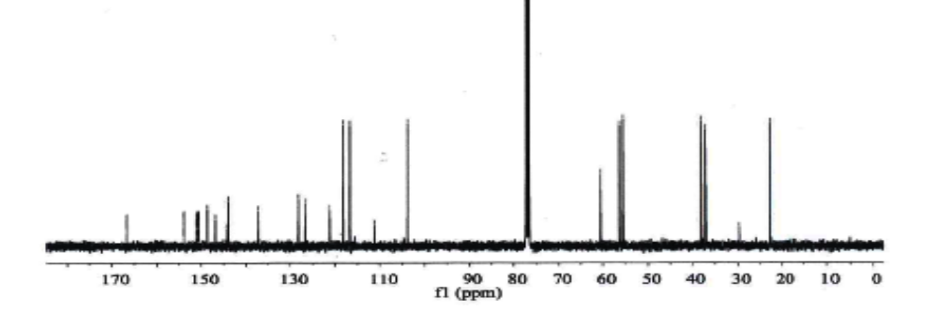

Figure S2: ¹³C-NMR (125 MHz, CDCl₃) Spectrum of Compound 1 (Amocurine A)

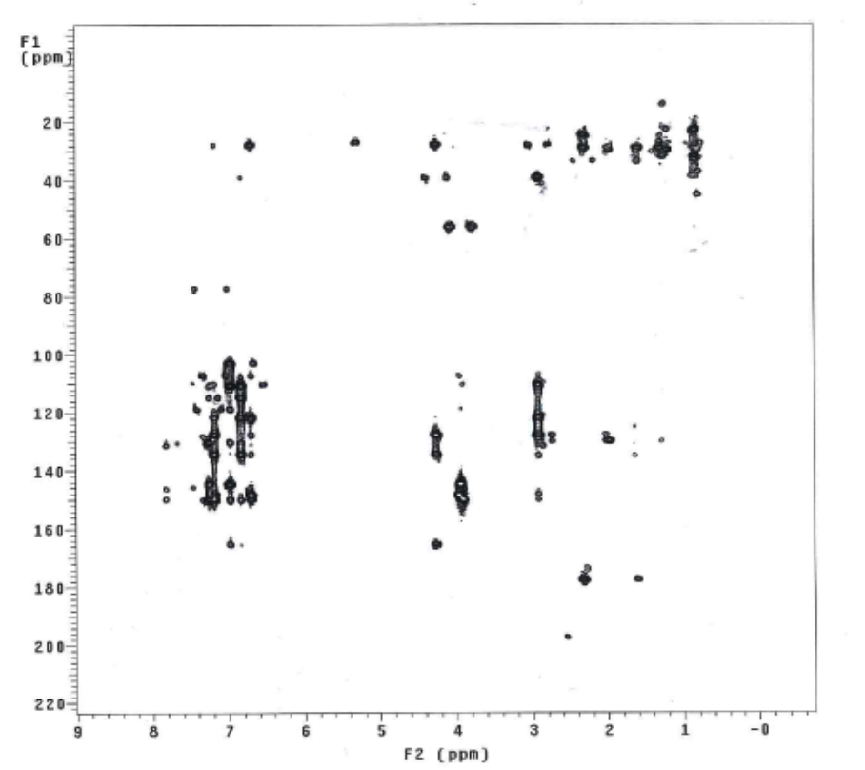

Figure S3: HMBC (500 MHz, CDCl₃) Spectrum of Compound 1 (Amocurine A)

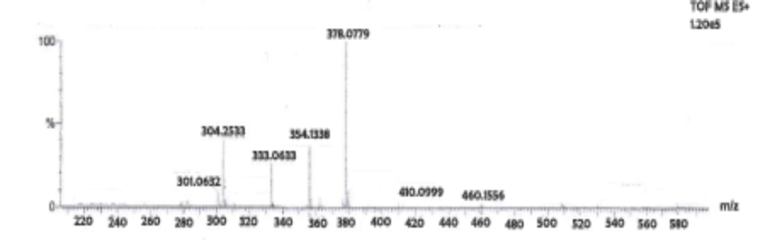

Figure S4: HRESI-MS Spectrum of Compound 1 (Amocurine A)

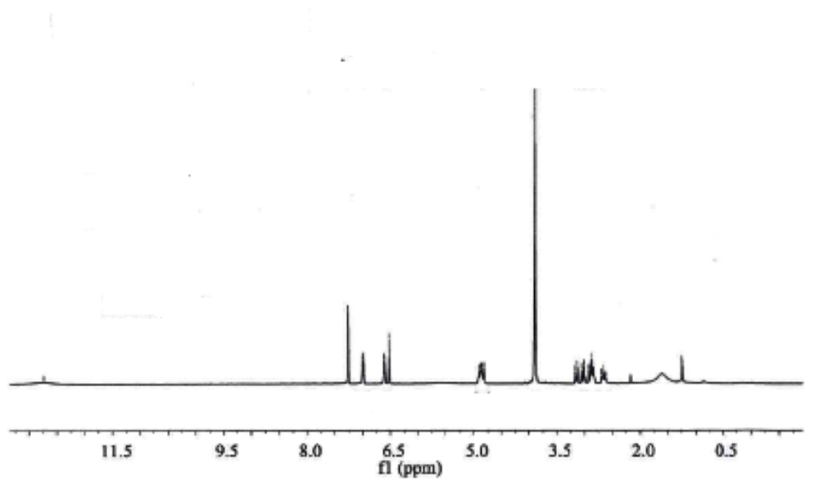
Figure S5: ¹H-NMR (500 MHz, CDCl₃) Spectrum of Compound 2 (Amocurine B)

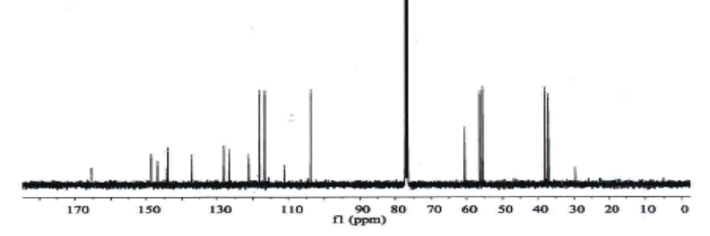

Figure S6: ¹³C-NMR (125 MHz, CDCl₃) Spectrum of Compound 2 (Amocurine B)

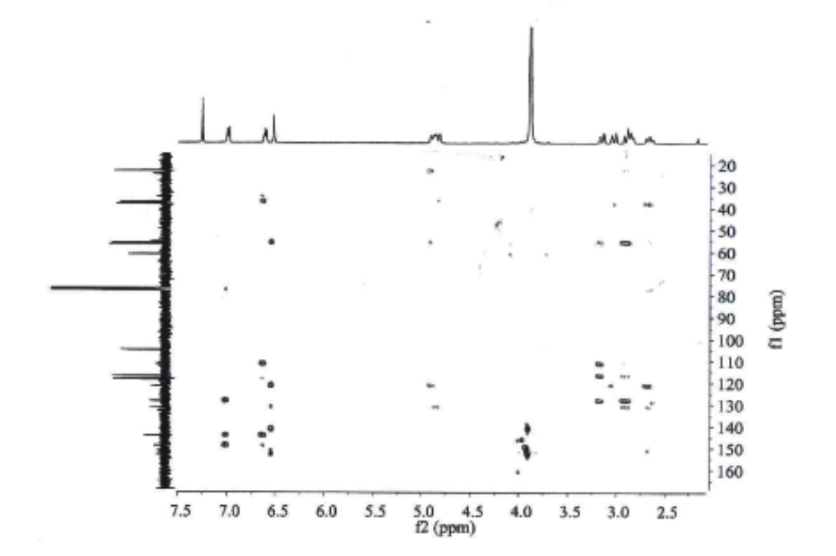
Figure S7: HMBC (500 MHz, CDCl₃) Spectrum of Compound 2 (Amocurine B)

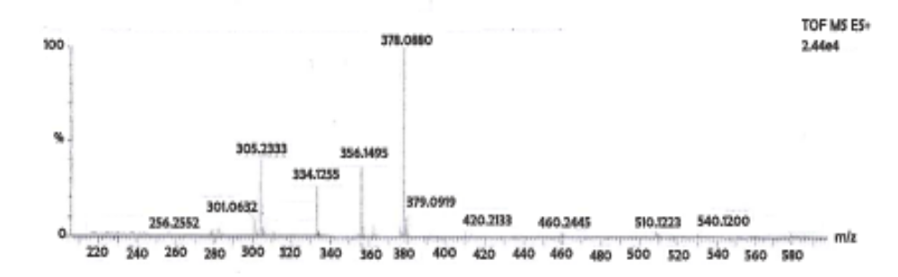

Figure S8: HRESI-MS Spectrum of Compound 2 (Amocurine B)

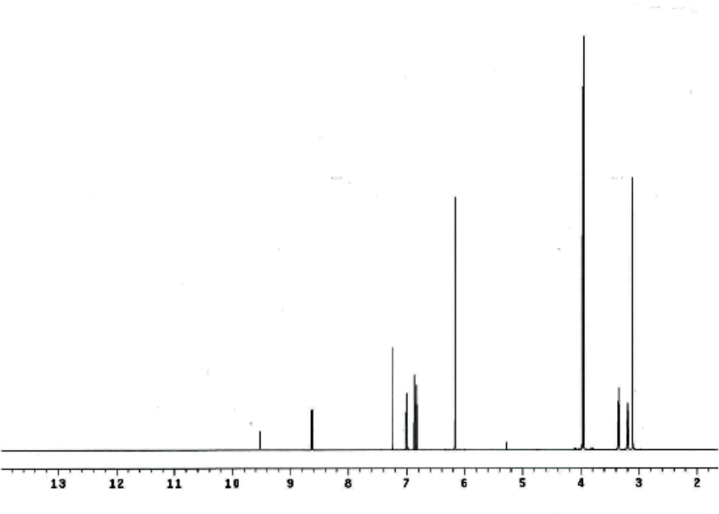

Figure S9: ¹H-NMR (500 MHz, CDCl₃) Spectrum of Compound 3 (Amocurine C)

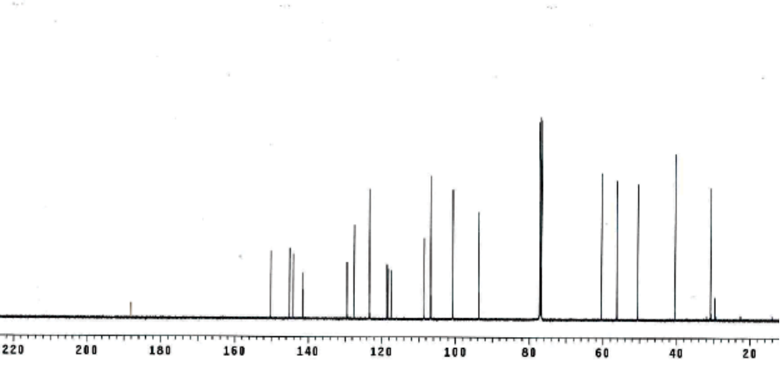

Figure S10: ¹³C-NMR (125 MHz, CDCl₃) Spectrum of Compound 3 (Amocurine C)

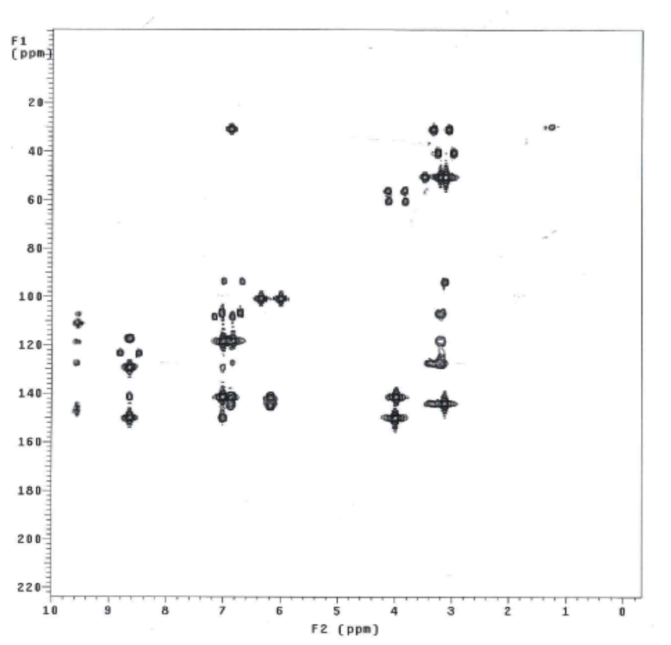

Figure S11: HMBC (500 MHz, CDCl₃) Spectrum of Compound 3 (Amocurine C)
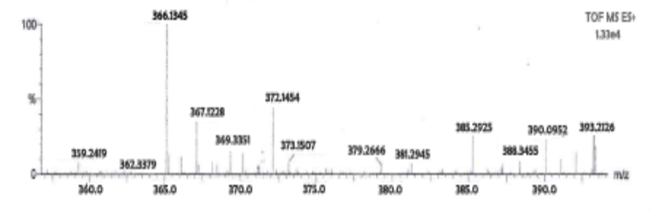

Figure S12: HRESI-MS Spectrum of Compound 3 (Amocurine C)

