 | Rec. Nat. Prod. X:X (202X) XX-XX | 

Isopimarane diterpenoids and pyranones from the endophytic fungi Xylaria curta E10
Qing Liu ¹, Yin-Zhong Fan ¹, Hong-Lian Ai¹, Bao-Bao Shi, ^{1,2,*}and Ji-Kai Liu ^{1,2,*}

¹School of Pharmaceutical Sciences, South-Central MinZu University, Wuhan 430074, People’s Republic of China
² International Cooperation Base for Active Substances in Traditional Chinese Medicine in Hubei Province, School of Pharmaceutical Sciences, South-Central Minzu University

(Received Month Day, 202X; Revised Month Day, 202X; Accepted Month Day, 202X)
Abstract: Chemical studies on ethyl acetate extract of solid-state fermentation of Xylaria curta E10 resulted in isolation of two undescribed isopimarane diterpenoids (1 and 2) and two known pyranones (3 and 4). The structures of compounds 1 and 2 were established by spectral data analysis and quantum chemical calculations. The cytotoxic and anti-inflammatory activity of compounds 1 and 2 were evaluated.
Keywords: Xylaria curta E10; isopimarane diterpenoids; pyranones. © 201X ACG Publications. All rights reserved.

1. Fungi Source

Xylaria curta E10, an endophytic fungus, was isolated from the healthy potato plants collected in Lincang City, Yunnan Province, China. This isolate was identified according to the ITS sequence (GenBank Accession No. KJ883611.1, query cover 100%, maximum identity 99%). Subsequently, it was deposited in the Research Group of Medicinal Fungi and Ethnic Medicine, School of Pharmacy, South Central Minzu University.

- Previous Studies

Xylaria, a highly diverse genus within the family Ascomycota, plays significant ecological roles across various ecosystems [1]. Since 1978, over 300 Xylaria species have been identified globally, predominantly inhabiting temperate, tropical and subtropical regions [2]. Extensive research has revealed the genus' remarkable capacity to produce structurally diverse and biologically active secondary metabolites. Notable examples include sesquiterpenes exhibiting anti-inflammatory properties [3], anti-Plasmodium falciparum sesquiterpene lactones [4], antimicrobial pyrantel derivatives effective against Escherichia coli and Staphylococcus aureus [5], and tricyclic polyketides demonstrating antitumor potential [6]. Additionally, other compound classes such as diterpenes [7], ergosterols [8], anthraquinones [9], and alkaloids [10] have been characterized from this genus.
Building upon our research group's prior work isolating bioactive secondary metabolites from Xylaria curta E10 [11-13], we further investigated this strain's biosynthetic potential through the one strain many compounds (OSMAC) strategy. By employing solid-state fermentation, we aimed to induce novel secondary metabolite production. Here, we report the isolation, structural elucidation, and bioactivity assessment of two previously undescribed isopimarane diterpenoids and two known pyranones.

- Present Study

In this study, four compounds including two new isopimarane diterpenoids (1 and 2) as well as two known pyranones (3 and 4) (Figure 1) were isolated from rice solid-state fermentation of Xylaria curta E10. This study reports the isolation, structural elucidation, and biological activities of the isolates were reported.
Xylaria curta E10 was inoculated into PDA agar medium and incubated at 25 ℃ for 3-5 days. Then the medium was cut into several small pieces, access to solid rice medium (50 g rice and 50 ml water into 500 ml culture bottles, 120 ℃ autoclaved for 30 minutes, a total of 200 bottles) in the dark culture at 25 ℃ fermentation 30 days. The rice medium was mashed, extracted five times with 2-fold volume of EtOAc, and concentrated under reduced pressure to obtain 220 g of crude extract. The EtOAc extract was treated with 80-100 mesh normal-phase silica gel and eluted with a gradient of CH₂Cl₂-MeOH (100:0-0:100, v/v) to obtain five fractions (A-E).
Fraction D (30.6 g) was subjected to C₁₈ MPLC using MeOH–H₂O (10:90 – 100:0, v/v) yielding nine subfractions (D-1 – D-9). Subsequent petroleum ether-acetone (30:1-0:1, v/v), which was used as a normal-phase column eluent, divided fraction D-3 (8.8 g) into ten subfractions (D-3-1 – D-3-10). Then, the choice was made to continue the separation of D-3-3 (3.2 g) by normal phase silica gel column chromatography with the gradient of petroleum ether-EtOAc (20:1 - 0:1, v/v), which resulted in the separation of eight additional fractions (D-3-3-1 – D-3-3-8). Fraction D-3-3-3 (70.3 mg), Which was purified consecutively with preparative HPLC with Agilent C₁₈ column to afford compound 1 (1.2 mg, t_{R} = 10.8 min) and compound 2 (3.5 mg, t_{R} = 13.6 min).Fraction D-3-3-4 (83.4 mg), Which was purified consecutively with preparative HPLC with Agilent C₁₈ column to afford compound 3 (1.6 mg, t_{R} = 14.5 min) and compound 4 (2.0 mg, t_{R} = 18.8 min).

Equipment: The HPLC model is an Agilent 1260 liquid chromatograph with a DAD detector and a Zorbax SB-C18 preparative column (4.6 mm×150 mm, 5 µm). The model of medium-pressure liquid chromatography was Biotage SP1 (Biotage, Sweden) with an RP-18 column (Fuji Silysia Chemical Ltd., Japan). Column chromatography was conducted using silica gel (80–100 mesh and 200–300 mesh, Qingdao Marine Chemical Factory, China), Sephadex LH-20 (Pharmacia Fine Chemical Co, Sweden). Thin-layer chromatography (TLC) was performed on GF254 plates (Qingdao Marine Chemical Factory, China). 1D and 2D spectra were produced by a Bruker spectrometer (Bruker, Germany, model AM600). HR-ESI-MS data were collected by A Q Exactive HF (Thermo Fisher Scientific, USA). The optical circular dichroism (OCD) was measured by a Horiba SEPA-300 polarimeter, and the circular dichroism spectrum was recorded through a Chirascan circular dichroism spectrometer (USA, New Haven).

Curtaterpene A (1): white amorphous powder; mp. 180–183 ℃; UV (MeOH) λ_{max} (log ε) = 235 (3.36) nm; [α]18 D -28 (c 0.4, MeOH); ¹H NMR (600 MHz, CDCl₃): δ (ppm) = 6.05 (1H, dd, J = 9.9, 2.2 Hz, H-6), 5.95 (1H, dd, J = 10.2, 3.0 Hz, H-7), 5.32 (1H, s, H-14), 3.70 (2H, t, H-16, J = 7.3 Hz), 2.21 (1H, d, H-1a, J = 13.5 Hz), 2.15 (1H, s, H-5), 1.94 (1H, m, H-9), 1.84 (1H, dt, J = 13.9, 3.7 Hz, H-2b), 1.74 (1H, d, J = 7.3 Hz, H-1b), 1.63 (1H, m, H-11a), 1.60 (2H, m, H-15), 1.53 (1H, m, H-2a), 1.48 (2H, d, J = 2.8 Hz, H-12), 1.36 (1H, m, H-11b), 1.31 (3H, s, H-18), 1.07 (2H, dd, J = 13.6, 4.8 Hz, H-3), 0.98 (3H, s, H-17), 0.62 (3H, s, H-20); ¹³C NMR (150 MHz, CDCl₃): δ (ppm) = 37.5 (CH₂, C-1), 19.6 (CH₂, C-2), 37.5 (CH₂, C-3), 43.4 (C, C-4), 55.4 (CH, C-5), 127.7 (CH, C-6), 128.2 (CH, C-7), 134.9 (C, C-8), 49.2 (CH, C-9), 37.7 (C, C-10), 19.0 (CH₂, C-11), 34.0 (CH₂, C-12), 34.4 (C, C-13), 134.2 (CH, C-14), 46.2 (CH₂, C-15), 60.0 (CH₂, C-16), 28.1 (CH₃, C-17), 28.3 (CH₃, C-18), 182.1 (C, C-19), 11.9 (CH₃, C-20); HRESIMS: m/z 319.22675 [M + H] ⁺ (calcd for C₂₀H₃₁O₃, 319.22677).

Curtaterpene B (2): white amorphous powder; mp. 185–188 ℃; UV (MeOH) λ_{max} (log ε) = 240 (2.83); [α]18 D -19 (c 0.4, MeOH); ¹H NMR (600 MHz, CD₃OD): δ (ppm) = 1.94 (1H, m, H-1b), 1.36 (1H, m, H-1a), 2.01 (1H, m, H-2a), 1.54 (1H, m, H-2b), 2.14 (1H, m, H-3a), 1.04 (1H, m, H-3b), 1.47 (1H, m, H-5), 2.72 (1H, m, H-6b), 2.33 (1H, m, H-6a), 5.48 (1H, m, H-7), 5.44 (1H, m, H-11), 2.04 (1H, m, H-12a), 1.90 (1H, m, H-12b), 4.03 (2H, m, H-14), 1.54 (1H, m, H-15a), 1.46 (1H, m, H-15b), 3.61 (2H, m, H-16), 0.90 (3H, s, H-17), 1.19 (3H, s, H-18), 0.90 (3H, s, H-20); ¹³C NMR (150 MHz, CD₃OD): δ (ppm) = 38.8 (CH₂, C-1), 21.1 (CH₂, C-2), 39.4 (CH₂, C-3), 45.0 (C, C-4), 51.7 (CH, C-5), 25.9 (CH₂, C-6), 124.5 (CH, C-7), 139.1 (C, C-8), 146.7 (C, C-9), 38.4 (C, C-10), 118.0 (CH, C-11), 40.4 (CH₂, C-12), 32.6 (C, C-13), 45.2 (CH₂, C-14), 42.5 (CH₂, C-15), 59.5 (CH₂, C-16), 26.6 (CH₃, C-17), 29.4 (CH₃, C-18), 181.5 (C, C-19), 20.8 (CH₃, C-20); HRESIMS: m/z 317.21222 [M – H] ⁺ (calcd for C₂₀H₂₉O₃, 317.21338).

4-methoxy-6-pentanoyl-2H-pyran-2-one (3): Yellow oil; ¹H NMR (600 MHz, CDCl₃): δ (ppm) = 6.76 (1H, d, J = 2.4 Hz, H-5), 5.70 (1H, d, J = 2.4 Hz, H-3), 3.85 (3H, s, H-12), 2.89 (2H, t, J = 7.4 Hz, H-8), 1.64 (2H, m, H-9), 1.37 (2H, m, H-10), 0.93 (3H, t, J = 7.3 Hz, H-11); ¹³C NMR (150 MHz, CDCl₃): δ (ppm) = 194.1 (C, C-7), 170.0 (C, C-4), 162.6 (C, C-2), 154.8 (C, C-6), 103.9 (CH, C-5), 93.6 (CH, C-3), 56.5 (CH₃, C-12), 38.1 (CH₂, C-8), 25.3 (CH₂, C-9), 22.3 (CH₂, C-10), 14.0 (CH₃, C-11).The above data was consistent with literature data [14].

6-pentyl-4- methoxy-pyran-2-one (4): Yellow oil; ¹H NMR (600 MHz, CD₃OD): δ (ppm) = 5.99 (1H, d, J = 2.2 Hz, H-5), 5.51 (1H, d, J = 2.2 Hz, H-3), 3.83 (3H, s, H-12), 2.47 (2H, t, J = 7.6 Hz, H-7), 1.63 (2H, m, H-8), 1.33 (4H, m, H-9, 10), 0.90 (3H, t, J = 7.0 Hz, H-11); ¹³C NMR (150 MHz, CD₃OD): δ (ppm) = 174.0 (C, C-4), 167.8 (C, C-2), 167.5 (C, C-6), 101.3 (CH, C-5), 88.1 (CH, C-3), 56.9 (CH₃, C-12), 34.3 (CH₂, C-7), 32.2 (CH₂, C-9), 27.6 (CH₂, C-8), 23.4 (CH₂, C-10), 14.3 (CH₃, C-11).The above data is consistent with literature data [15].

Figure 1. The chemical structures of compounds 1–4.
Figure 2. Key HMBC, ¹H-¹H COSY and ROESY correlations of compounds 1–2.
Curtaterpene A (1) was obtained as a white amorphous powder. The molecular formula was determined to be C₂₀H₃₀O₃ by the positive HR-ESI-MS (m/z 319.22675 [M + H] ⁺, calculated for C₂₀H₃₁O₃, 319.22677), indicating a molecular unsaturation index of six. By comparing the 1D NMR spectroscopic data, the data of compound 1 was similar to that of hymatoxin D [16], a known isopinacrine diterpene compound, suggesting that the parental skeleton of compound 1 was consistent with that of hymatoxin D. Further analysis of HMBC and ¹H-¹H COSY correlation data determined the planar structure of compound 1. To begin with, according to the ¹H-¹H COSY correlation between H₂-15/H₂-16, H₂-12/H₂-11/H-9 and H₂-1/H₂-2/H₂-3, the linkage shown in the figure 2 was identified. Then the coupling interactions of H₃-18 with C-3/C-4/C-5/C-19 and H₃-20 with C-1/C-5/C-9/C-10 in the HMBC spectrum were observed, confirming the presence of two six-membered rings. Furthermore, the existence of the C ring was established through HMBC correlations between H₃-17 and C-12/C-13/C-14/C-15. Meanwhile, ROESY spectrum showed the correlation of H₃-20/H-11β/H3-17/H-2β and H₃-18/H-5/H-9 as well as the non-correlation of H₃-20/H-9, which determined the relative configuration of the compound. Finally, the absolute configuration of the compound was determined through ECD calculation (Fig 3).
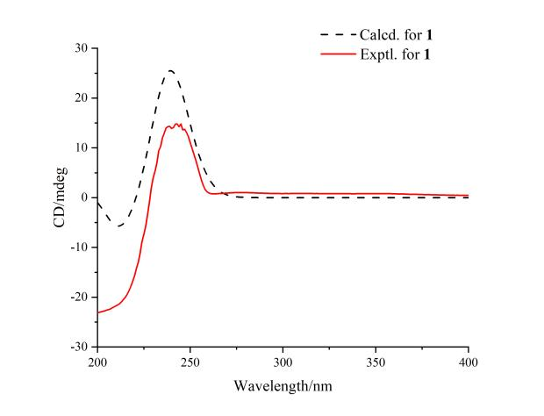
Figure 3. Experimental and calculated ECD curves of compounds 1.
Curtaterpene B (2), a white amorphous powder, presented the HR-ESI-MS [M – H] – ion at m/z 317.21222 (calculated for C₂₀H₂₉O₃, 317.21338) in the HRESI data, indicating a molecular unsaturation index of six. ¹³C NMR and DEPT revealed 20 carbons, which included three methyl signals [δ_{C} 20.8 (C-20), 26.6 (C-17), 28.4 (C-18), eight methylene signals [δ_{C} 21.1 (C-2), 25.9 (C-6), 38.8 (C-1), 39.4 (C-3), 40.0 (C-12), 42.5 (C-14), 45.2 (C-14), 59.5 (C-16), one hypomethyl signal [δ_{C} 51.7 (C-5), three quaternary carbon signals [δ_{C} 32.6 (C-13), 38.4 (C-10), 40.5 (C-4), four olefinic carbon signals [δ_{C} 118.0 (C-11), 124.5 (C-7), 131.9 (C-8), 146.7 (C-9), and one carbonyl carbon signal [δ_{C} 181.5 (C-19)]. The ¹D NMR spectroscopic data of 2 were similar to those of compound 1 except for the position of the double bonds. Regarding the identification of double bond positions, firstly, HMBC spectrum showed the correlation of H₃-20 with C-1/C-5/C-9/C-10, H₃-17 with C-12/C-13/C-14/C-15 and H₂-12 with C-5/C-10/C-7/C-8. Secondly, the ¹H-¹H COSY spectrum showed H-11/H₂-12 correlation, determining two double bonds of 2 at C-7/C-8 and C-9/C-11. ROESY spectrum showed the correlations of H₃-20/H₂-6β/, H₂-6β/H₂-1β and H₂-6α/H₃-18/, H₃-18/H-5, which determined the relative configuration of compound 2. Finally, the absolute configuration of the compound 2 was determined through ECD calculation (Fig 4).
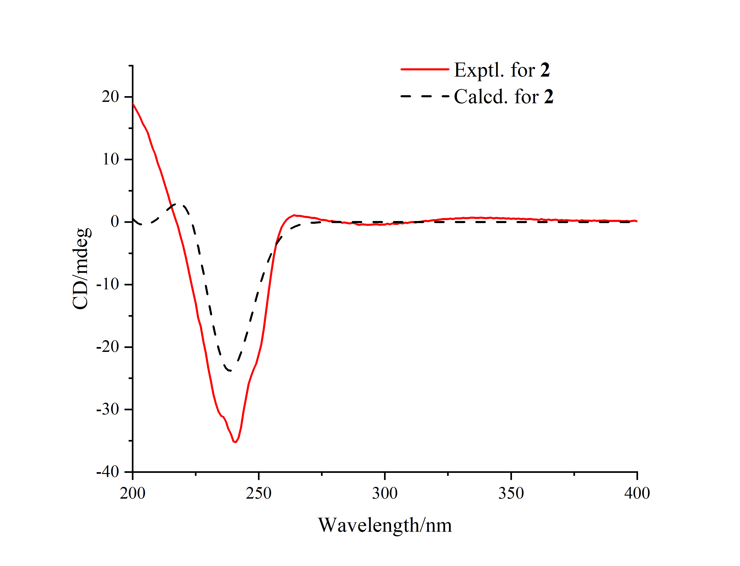
Figure 4. Experimental and calculated ECD curves of compounds 2.

In the activity testing section, curtaterpenes A (1) and B (2) were tested for cytotoxic activity and anti-inflammatory activity. Both the compounds did not show significant activity in cytotoxicity and anti-inflammatory tests at a concentration of 40 µM.

Acknowledgments
This work was financially supported by the Hubei Provincial Natural Science Foundation of China (2022CFB920), and South-Central University for Nationalities (YZY24019).

Supporting Information

Supporting Information accompanies this paper on http://www.acgpubs.org/journal/records-of-natural-products

ORCID

Qing Liu: 0009-0004-3573-0596
Yin-Zhong Fan: 0009-0007-5878-111X
Hong-Lian Ai: 0000-0003-2670-2054
Bao-Bao Shi: 0000-0001-9138-5628
Ji-Kai Liu: 0000-0001-6279-7893

References
[1] W. K. Chen, M. Yu, S. J. Chen, T. M. Gong, L. L. Xie, J. Q. Liu, C. Bian, G. L. Huang, C. J. Zheng (2024). Structures and biological activities of secondary metabolites from Xylaria spp., J. Fungi 10, 190.
[2] W. Y. Zeng, K. Habib, X. Zhou, Y. L. Ren, X. C. Shen, B. Wang, Y. Q. Kang, J. C. Kang, Q. R. Li (2024). Morphology and multigene phylogeny reveal four new Xylaria (Xylariales, Xylariaceae) species from karst region in China, MycoKeys 108, 169-196.
[3] J. C. Chang, G. Hsiao, R. K. Lin, Y. H. Kuo, Y. M. Ju, T. H. Lee (2017). Bioactive constituents from the termite nest-derived medicinal fungus Xylaria nigripes. J. Nat. Prod. 80, 38-44.
[4] P. Pittayakhajonwut, A. Usuwan, C. Intaraudom, S. Veeranondha, P. Srikitikulchai (2009). Sesquiterpene lactone 12, 8-eudesmanolides from the fungus Xylaria ianthinovelutina. Planta Med. 75, 1431-1435.
[5] N. Zheng, Q. Liu, D. L. He, Y. Liang, J. Li, R. Y. Yang (2018). A new compound from the endophytic fungus Xylaria sp. from Sophora tonkinensis. Chem. Nat. Compd. 54, 447-449.
[6] J. Li, L. Q. Li, G. S. Tan, S. Liu, W. X. Wang, J. K. Liu (2021). Longipone A, a unique tricyclic polyketide from the fungus Xylaria longipes. Tetrahedron Lett. 73, 153114.
[7] Y. S. Chen, H. S. Chang, M. J. Cheng, H. Y. Chan, M. D. Wu, S. Y. Hsieh, H. C. Wang, I. S. Chen (2016). New chemical constituents from the endophytic fungus Xylaria papulis Cultivated on Taiwanese Lepidagathis stenophylla. Rec. Nat. Prod. 10, 735-743.
[8] J. Sorres, C. Nirma, S. Touré, V. Eparvier, D. Stien (2015). Two new isopimarane diterpenoids from the endophytic fungus Xylaria sp. SNB-GTC2501. Tetrahedron Lett. 56, 4596-4598.
[9] X. S. Huang, X. F. Sun, S. E. Lin, Z. E. Xiao, H. X. Li, D. Bo, Z. G. She (2014). Xylanthraquinone, a new anthraquinone from the fungus Xylaria sp. 2508 from the South China Sea. Nat. Prod. Res. 28, 111-114.
[10] S. Sodngam, S. Sawadsitang, N. Suwannasai, W. Mongkolthanaruk (2014). Chemical constituents, and their cytotoxicity, of the rare wood decaying fungus Xylaria humosa. Nat. Prod. Commun. 9, 157-158.
[11] W. X. Wang, Z. H. Li, T. Feng, J. Li, H. Sun, R. Huang, J. K. Liu (2018). Curtachalasins A and B, two cytochalasans with a tetracyclic skeleton from the endophytic fungus Xylaria curta E10. Org. Lett. 20, 7758-7761.
[12] P. P. Wei, H. L. Ai, B. B. Shi, K. Ye, X. Lv, X. Y. Pan, X. X. Lei (2022). Paecilins F–P, new dimeric chromanones isolated from the endophytic fungus Xylaria curta E10, and structural revision of paecilin A. Front. Microbiol. 13, 922444.
[13] X. Zhang, Y. Z. Fan, K. Ye, X. Y. Pan, X. J. Ma, H. L. Ai, B. B. Shi, J. K. Liu (2023). Six unprecedented cytochalasin derivatives from the potato endophytic fungus Xylaria curta E10 and their cytotoxicity. Pharmaceuticals 16, 193.
[14] J. F. Tian, R. J. Yu, X. X. Li, H. Gao, L. D. Guo, J. S. Tang, X. S. Yao (2015). ¹H and ¹³C NMR spectral assignments of 2‐pyrone derivatives from an endophytic fungus of sarcosomataceae. Magn. Reson. Chem. 53, 866-871.
[15] A. Evidente, M. C. Zonno, A. Andolfi, C. Troise, A. Cimmino, M. Vurro (2012). Phytotoxic α-pyrones produced by Pestalotiopsis guepinii, the causal agent of hazelnut twig blight. J. Antibiot. 65, 203-206.
[16] K. Borgschulte, S. Rebuffat, W. Trowitzsch-Kienast, D. Schomburg, J. Pinon, B. Bodo (1991). Isolation and structure elucidation of hymatoxins B-E and other phytotoxins from Hypoxylon mammatum fungal pathogen of leuce poplars. Tetrahedron 47, 8351-8360.
© 202X ACG Publications

