Supporting Information
J. Chem. Metrol. X:X (2025) XX-XX
Determination of total active oligosaccharide content of cream formulation of Triticum Vulgare extract by ion chromatography

Yeter Arten, Şafak Şanlı and Nurhan Metan

Abdiibrahim İlaç Sanayi Quality Control Analytical Method Validation and Technology Transfer Laboratory, 34519 Istanbul, Türkiye

Table of Contents | Page
Figure S1 : Linearity graph of the method | 2
Table S1: Repeatability data of the applied method  Figure S2 : Triticum Vulgare extraction certificate | 2  3

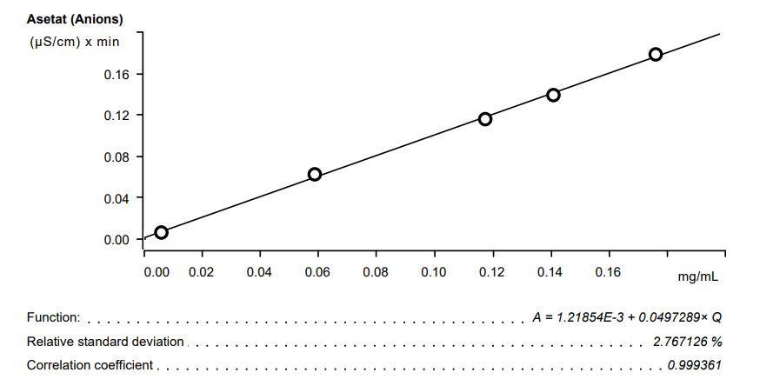
Figure S1 : Linearity graph of the method

Table S1 : Repeatability data of the applied method
Solution Name |  | Result (%)
Triticum vulgare extract | 1.10
Triticum vulgare extract | 1.07
Triticum vulgare extract | 1.07
Triticum vulgare extract | 1.06
Triticum vulgare extract | 1.07
Triticum vulgare extract | 1.08
Average | 1.08
RSD %:1.3
SD: 0.01
Confidence Interval ((%95) : 1.08±0.01

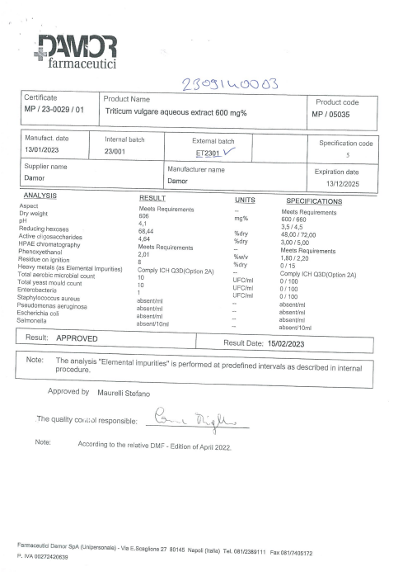
Figure S2 : Triticum Vulgare extraction certificate

